1. Password expiration is now set to 6 months instead of 3 months.

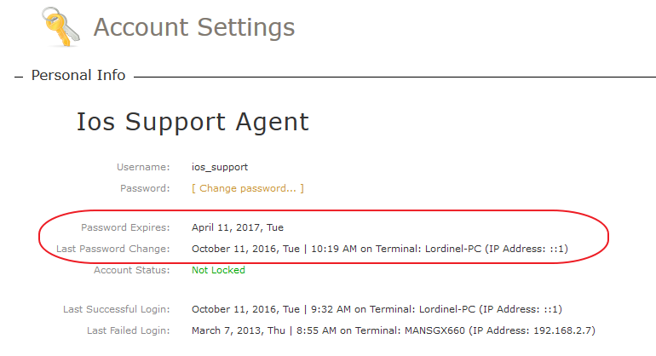

1. New menu item: Orders > With payments to collect and clear

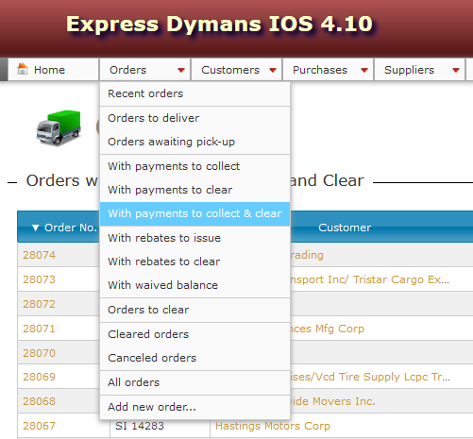

1. New menu item: Purchases > Purchases to pay and clear

